American University of Beirut
Department of Electrical and Computer Engineering
EECE 350 – Computer Networks
Spring 2015

HOMEWORK 2 SOLUTION

Problem 1. [10 points]

- Using the 4B/5B and NRZI encoding schemes, and assuming the signal is initially “Low”, show the waveform for the signal that gets transmitted when the message bits are your initials in ASCII. E.g., for Barrack Obama, the initials are BO and their binary equivalent is
0100 0010 010 01111. [5 points]

Using the initials given in the question for Barak Obama: B and O
Refer to the ASCII printable characters table (http://www.ascii-code.com):

- The Hexadecimal representation of B is 0x42.
- The Hexadecimal representation of O is 0x4F.

Using this table for translation:

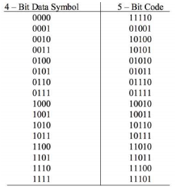

Presenting the Initials in binary 4B/5B encoding
B: 0100 0010 → 01010 10100
O: 0100 1111 → 01010 11101

NRZI encoding scheme: bit 1 triggers a change.
Initial signal assumed to be low.
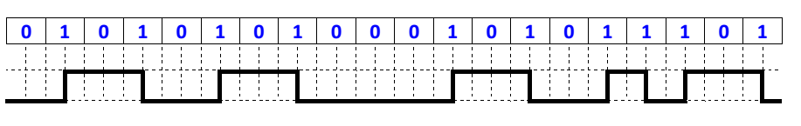

- Show the waveform when Manchester encoding is used for your initials in part a) above.
[5 points]

Manchester encoding scheme:
Bit 1 is represented by:
Bit 0 is represented by:

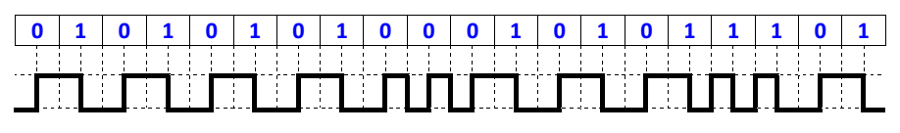

Problem 2. [15 points]

- What is the capacity (in bps) of a voice channel with a 3.3 kHz bandwidth and X dB Signal-to-Noise Ratio (SNR)? [5 points]
X = 32 + (last two digits of your ID number)/50 2014 12345 => X = 32+45/50=32.9

Assuming X = 32 + 45/50 = 32.9

B= 3.3 KHz

$$SNR= {10}^{x/10}={10}^{32.9/10}=1949.8446$$

$$C=B×\log_{2}\left(1+SNR\right)=3300×\log_{2}{1950.8446}=36068.61438 bps$$

- How many signal levels are needed to achieve such capacity? [5 points]

$$C=2×B×\log_{2}{V} →V=2^{C/2B}=2^{36068.61437/6600}=44.168$$

But V should be a power of 2. Hence we take the next power of 2 greater than the one we found (44.168)

Hence $V=2^{6}=64$ signal levels

- What is the noise-free capacity with so many signal levels? [5 points]

$$C_{noise-free}=2×B×\log_{2}{V=2×3300×\log_{2}{64}}=39600 bps$$

Problem 3. [25 points]

Install Python 2.7 and run the code shown in class that retrieves the Apple Inc. (symbol AAPL) share price from the Yahoo! finance server. Note that the share price is shown on line 13 of the output after the “AAPL” symbol.
Modify the code to retrieve the share price of the company whose information appears next to your ID number in the file posted on Moodle. You can verify that your share price is correct by using the nasdaq.com URL, also shown in the file.
Submit your source code and the output that shows the share price of your assigned company.

Assuming we choose “ALLT”.

Python Input:

import socket
server = "download.finance.yahoo.com"
port = 80
request_string = "GET /d/quotes.csv?s=ALLT&f=sl1HTTP/1.1 \r\nHost:download.finance.yahoo.com\r\n\r\n"
receive_buffer_size = 4096
mysocket = socket.socket( socket.AF_INET, socket.SOCK_STREAM )
mysocket.connect( ( server, port ) )
mysocket.send( request_string )
response_string = mysocket.recv( receive_buffer_size )
mysocket.close
print response_string

Python Execution Output:

HTTP/1.1 200 OK
Date: Wed, 11 Mar 2015 07:53:06 GMT
P3P: policyref="http://info.yahoo.com/w3c/p3p.xml", CP="CAO DSP COR CUR ADM DEV TAI PSA PSD IVAi IVDi CONi TELo OTPi OUR DELi SAMi OTRi UNRi PUBi IND PHY ONL UNI PUR FIN COM NA
V INT DEM CNT STA POL HEA PRE LOC GOV"
Cache-Control: private, no-cache, no-store
Content-Type: application/octet-stream
Age: 0
Transfer-Encoding: chunked
Connection: keep-alive
Via: http/1.1 r31.ycpi.dxs.yahoo.net (ApacheTrafficServer [cMsSf ])
Server: ATS
000000d
"ALLT",9.03
0

Problem 4. [50 points]

Wireshark Lab.

This exercise is available online at:

http://www-net.cs.umass.edu/wireshark-labs/Wireshark_Intro_v6.0.pdf

- HTTP/TCP/UDP/ARP/DNS/SSDP/TLSv1/MDNS/… (only 3 required)

T= Time Stamp of OK message – Time Stamp of Get Message
= 0.610132-0.515158 = 0.094974 s

- gaia.cs.umass.edu: 128.119.245.12 // PC: private IP range: ex: 192.168.1.69

- We need HTTP GET and OK messages

GET Message:

No. Time Source Destination Protocol Length Info
41 10:02:57.515158000 192.168.1.69 128.119.245.12 HTTP 355 GET /wi
reshark-labs/INTRO-wireshark-file1.html HTTP/1.1
Frame 41: 355 bytes on wire (2840 bits), 355 bytes captured (2840 bits) on interface 0
Ethernet II, Src: LiteonTe_38:e2:e9 (9c:b7:0d:38:e2:e9), Dst: ThomsonT_ef:39:38 (00:1d:68:ef:3
9:38)
Internet Protocol Version 4, Src: 192.168.1.69 (192.168.1.69), Dst: 128.119.245.12 (128.119.24
5.12)
Transmission Control Protocol, Src Port: 50239 (50239), Dst Port: 80 (80), Seq: 1, Ack: 1, Len
: 301
Hypertext Transfer Protocol
GET /wireshark-labs/INTRO-wireshark-file1.html HTTP/1.1\r\n
Accept: text/html, application/xhtml+xml, */*\r\n
Accept-Language: en-US\r\n
User-Agent: Mozilla/5.0 (Windows NT 6.1; WOW64; Trident/7.0; rv:11.0) like Gecko\r\n
Accept-Encoding: gzip, deflate\r\n
Host: gaia.cs.umass.edu\r\n
DNT: 1\r\n
Connection: Keep-Alive\r\n
\r\n

OK Message:

No. Time Source Destination Protocol Length Info
48 10:02:57.610132000 128.119.245.12 192.168.1.69 HTTP 502 HTTP/1.
1 200 OK (text/html)
Frame 48: 502 bytes on wire (4016 bits), 502 bytes captured (4016 bits) on interface 0
Ethernet II, Src: ThomsonT_ef:39:38 (00:1d:68:ef:39:38), Dst: LiteonTe_38:e2:e9 (9c:b7:0d:38:e
2:e9)
Internet Protocol Version 4, Src: 128.119.245.12 (128.119.245.12), Dst: 192.168.1.69 (192.168.
1.69)
Transmission Control Protocol, Src Port: 80 (80), Dst Port: 50239 (50239), Seq: 1, Ack: 302, L
en: 448
Hypertext Transfer Protocol
HTTP/1.1 200 OK\r\n
Date: Wed, 11 Mar 2015 08:01:55 GMT\r\n
Server: Apache/2.4.6 (CentOS) OpenSSL/1.0.1e-fips PHP/5.4.16 mod_perl/2.0.9-dev Perl/v5.16
.3\r\n
Last-Modified: Wed, 11 Mar 2015 05:59:01 GMT\r\n
ETag: "51-510fcf6c2b170"\r\n
Accept-Ranges: bytes\r\n
Content-Type: text/html; charset=UTF-8\r\n
X-CFLO-Cache-Result: TCP_HIT\r\n
Content-Length: 81\r\n
Connection: Keep-Alive\r\n
Age: 64\r\n
\r\n
[HTTP response 1/1]
[Time since request: 0.094974000 seconds]
[Request in frame: 41]
Line-based text data: text/html
<html>\n
Congratulations! You've downloaded the first Wireshark lab file!\n
</html>\n

